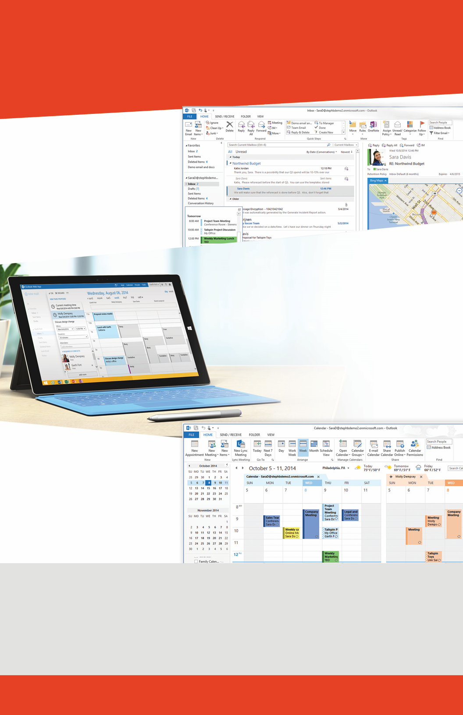Macintosh HD:Users:speaslee:Desktop:concept1.png­

* Word
* Excel
* PowerPoint

*Learn about the new aha features.*

*Join us for demos and hands-on labs.*

*\*Activate your KnowledgeWave Learning Account for a chance to win great prizes.*

* What’s the hype about Skype for Business? Learn the Basics.
* What’s the Buzz? Why the move to Office 365? Outlook Mobile and OWA.
* Learn What’s New in Office 2016.
* Open Lab – Activate your KnowledgeWave Learning account & ask questions.

9 AM | 12:30 PM | 3 PM   
9:30 AM | 1 PM | 3:30 PM  
10 AM | 1:30 PM | 4 PM  
10:30-12:30 PM | 2-3 PM

**Buzz Day Topics and Rolling Schedule**

Outlook & Skype for Business

* 15-minute demo sessions
* Your questions answered
* Hands-on opportunities
* Swag Giveaways
* + Xbox & Bluetooth Speaker Drawing*

**Where:** LOCATION **Starting at:** 9:00 AM

What’s new in Microsoft Office

The New Office 2016

* What’s the hype about Skype for Business?
* What’s the Buzz? Why the move to Office 365?
* A preview to Outlook on Mobile.
* The new Outlook Web Access (OWA) experience.

**Day, Month Year**

Join KnowledgeWave and Microsoft for a hands-on learning opportunity with Office 2016

Office 2016 Buzz Day Event