Office 365 E5 and PSTN Services Licensing

Frequently Asked Questions

**Field and Partner Use**Last updated: September 6, 2016

Contents

Office 365 E5 2

NEW Office 365 E5 SKU (as of 9/1) 5

Skype for Business Features 9

PSTN Conferencing and Calling Details 11

Feature Details 19

Customer Lockbox 19

Office 365 Advanced eDiscovery 19

Advanced Threat Protection 20

Power BI Pro 21

Delve Analytics 22

DLP and Encryption 23

Meeting Broadcast 23

Office 365 Planner 24

Office 365 Advanced Security Management 24

E5 Dynamics CRM Online Add on 24

## Office 365 E5

What is included in the Office 365 E5 suite?

Office 365 E5 is a new suite offering that includes new features value across three categories of investments in Real-time Communications, Analytics, and Advanced Security. Features across the categories are listed below:

* Voice – Cloud PBX, PSTN Conferencing, Skype Meeting Broadcast, and PSTN Calling as an add-on based on geo and channel availability
* Analytics – Analytics with Power BI and Individual and Team Analytics with Delve Analytics
* Security – Office 365 Advanced eDiscovery, Advanced Security Management, safe attachments and safe URLs with Advanced Threat Protection, and access control with Customer Lockbox

Highlighted in orange below, you will see all the new features across our enterprise suites.

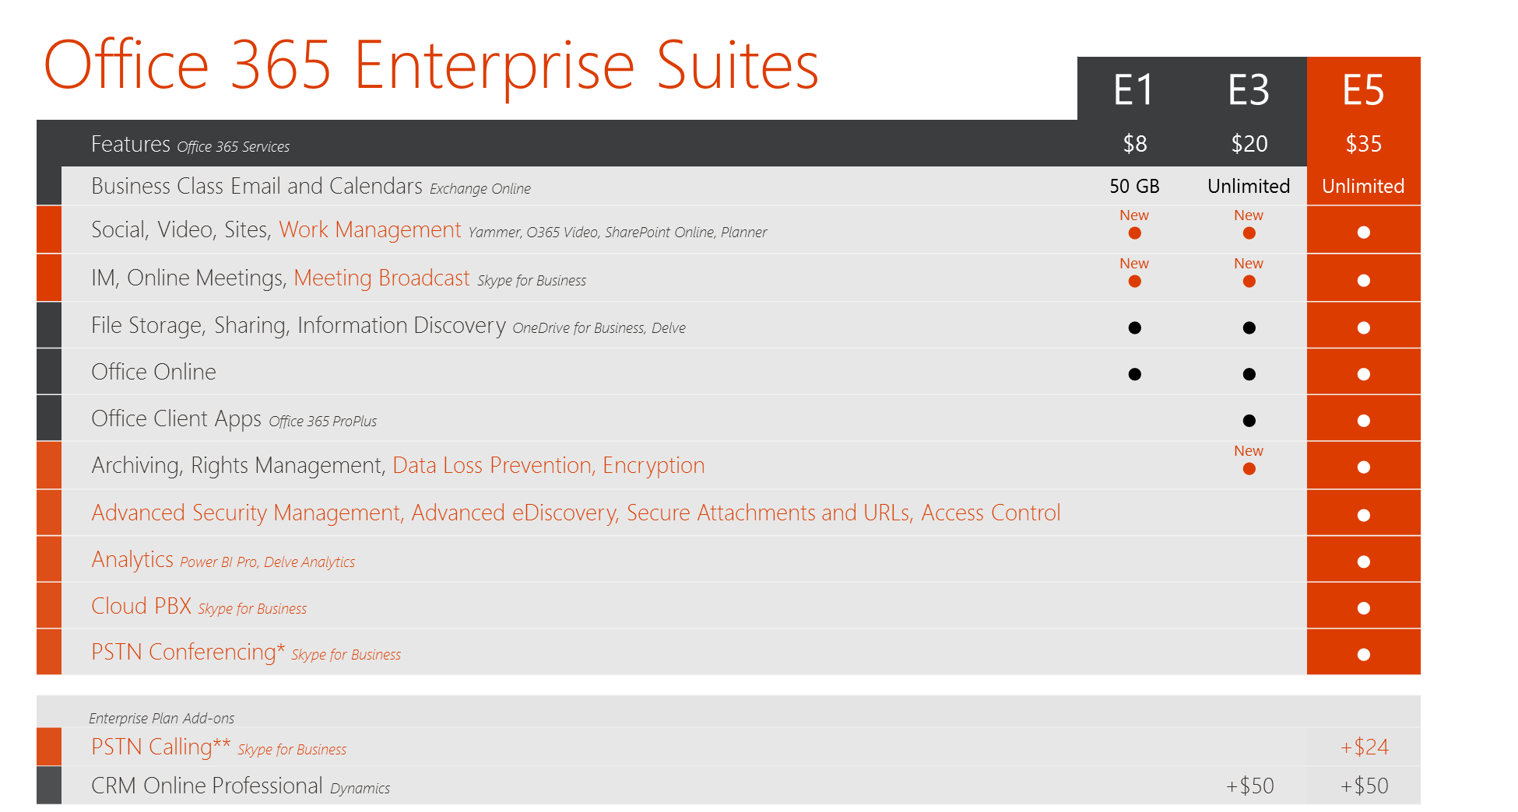

*Toll-free and International Dial-out conferencing capabilities will incur additional per minute consumption charges when available. Customers can disable this feature to avoid additional billing.

**$24 includes both International and Domestic calling plans. Domestic only calling plans are available for $12. Tax is included in price in USA. Add-On price to E1 & E3 is $32, which includes Cloud PBX

Why are ATP and Customer Lockbox not included in E3?

ATP and Customer Lockbox are advanced features that are considered premium services and therefore are only included in the E5 suite. While we do not include those services in the E3 suite, we do allow Office 365 E3 customers to buy those services separately in order to complement their Office 365 E3 subscription.

In addition to the new features in E5, is there anything new in E1 and E3?

Yes, new feature value will be added into E1 and E3. For E1, we will be adding Skype Meeting Broadcast to enable E1 customers to host every kind of meeting from 1:1, 1:Many, to 1:Thousands. In addition, we will be adding Work Management to provide light-weight project management capabilities for teams. For E3, we will be expanding Data Loss Prevention and Encryption across both the Skype for Business and SharePoint Online workloads. Availability dates for DLP and Encryption in Skype for Business and SharePoint Online will be communicated at a later date.

When and where will Office 365 E5 be available?

E5 launched on December 1, 2015 and is currently in all licensing channels worldwide. PSTN Conferencing, a component of E5, has limited geo and channel availability. Please refer to the PSTN Conferencing and Calling Details section for more information.

Is E5 available to Government and GCC (Government Community Cloud – US only) customers?

Yes, E5 is available to Government customers on the commercial cloud.

However, Office 365 E5 is currently not available to GCC (US only) customers. E5 on GCC is planned for FY17.

Will E5 be available in Education?

Yes, E5 launched on 5/1/2016 for Education and Nonprofit customers.

What is going to happen to E4?

Microsoft will begin the process of sunsetting E4 beginning on December 1, 2015. E4 will continue to appear on the Price List until June 30th, 2016, after which it will no longer be available. Customers should continue using the Office 365 plan they are using today. When customers’ plans come up for renewal prior to June 30th, 2016, they should renew to their current plan or transition into E5 or into E3 with Skype for Business Plus CAL subscription.

Please refer to the [Office 365 E4 End of Life Licensing FAQ](https://microsoft.sharepoint.com/sites/infopedia/pages/layouts/KCDoc.aspx?k=G03KC-1-6501) for more information.

How can I upgrade to E5?

Existing Office 365 customers will be able to upgrade to E5 following our standard licensing motions. EA customers can upgrade via step-up SKUs that charge the difference between what the customer currently has and E5 as the step-up price to E5. Add-on SKUs will also be available with customers who are maintaining on-prem licenses with SA.

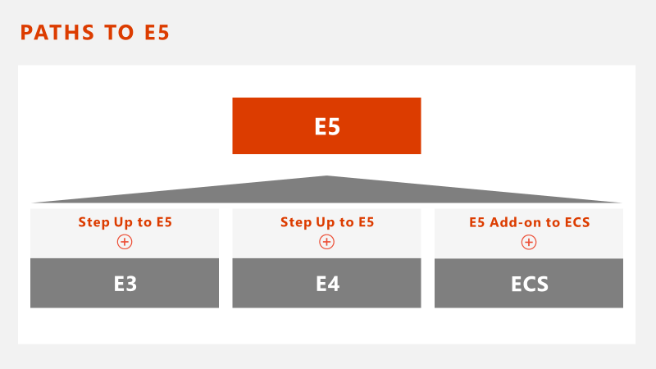

What is the path to E5 for a customer who purchased via an Add-on?

If a customer is currently licensed with E3, for example, via an Office 365 E3 Add-on SKU but wants to transition to the E5 Add-on, they would be able to do so by purchasing the Step-Up for E5 Add-on SKU at any time (mid-term, anniversary, renewal).

Will an Office 365 E5 trial be available?

Yes, Office 365 E5 trials are available.

What if a customer starts an E5 trial but in the end, only wants E3 with Cloud PBX?

If a customer begins an E5 trial but determines that they would only like to move forward with E3 and Cloud PBX, they would have to remove their users’ E5 licenses, begin a new E3 trial and then add Cloud PBX as a standalone. The original E5 trial would naturally come to an end when it expires and the customer would move forward with provisioning the E3 tenant into a paid subscription.

Will Small Business customers be able to purchase E5?

Yes, similar to E3 all customers will be able to purchase E5, but there will not be a new premium SKU specific for small business.

What if a customer wants just a few of the new capabilities in E5, yet is content with their current E1 or E3 coverage?

The new capabilities that are included in E5 can also be added as standalone to E1 and E3.

What if I purchase E5 but only want some of the components that are included?

E5 provides the best value for our customers and while each of the components will be available for customers to leverage at any point, the use of those components are at the customer’s discretion, enabling them to choose the options that best fits their needs.

Will the Adoption Offer apply specifically for the new Skype for Business workloads?

Yes.

How does E5 fit into the ECS model?

ECS customers will be able to purchase an E5 add-on for $15 which credits the price they have paid for Office 365 E3.

Do E5 and Cloud PBX come with dual-access rights?

Yes.  E5 and Cloud PBX come with dual-access rights to on premise servers and cloud services rights.

Can I use the new Office 365 Groups feature with my E5 license?

Yes. Office 365 Groups is available to all users licensed with Office 365 E5. For more information on Office 365 Groups, please see the detailed FAQ [here](https://microsoft.sharepoint.com/sites/infopedia/pages/layouts/kcdoc.aspx?k=G03KC-1-6746).

What Enterprise Service Offerings are available in support of E5?

Microsoft Services has offerings to help our customers get their Office 365 platforms up and running quickly and help drive value and usage of the communications platform. Current offerings aligned to E5 include:

* Skype for Business Foundations designs and implements an enterprise communications environment aligned to your customers’ workstyle, user base, and business needs. Enterprises can make use of rich collaboration features, both on premises and in the cloud, to deliver a consistent communications experience for all employees. This offer helps your customer to make use of recent Office 365 Enterprise E5 features such as Skype broadcast meetings, cloud conferencing, and cloud private branch exchange (PBX).
* Data Visualization Jumpstart demonstrates the power of the Microsoft Power BI and Datazen toolset for discovering data, creating compelling visualizations, and sharing insights. The jumpstart is meant to deliver quick value to customers by using their own data with familiar tools.

Additionally, our domain experts in MCS, Premier, and Adoption Services are able to support Skype for Business, Power BI and Security solutions.

How can I find more information on these Microsoft Services?

Leverage Domain Experts in Cloud Productivity Services across Office 365, Social, Enterprise Communications, and Adoption Services. Business Productivity Domain and Adoption Services resources with deep expertise and that are part of the Neptune Partner Program can help with Vision Setting, Business Outcome Selling, Solution and Adoption Acceleration. Locate a resource at: <http://aka.ms/servicesconnect>.

Find All Cloud Productivity and Adoption Services Offer Information: <http://aka.ms/portfolio-cp>.

## NEW Office 365 E5 SKU (as of 9/1/16)

What is the SKU plan for Office 365 E5 and how is it transacted for customers?

When Office 365 E5 launched in December 2015, E5 required two separate SKUs to be transacted: a $33 E5 w/out PSTN SKU and a $2 PSTN Conferencing Add-on SKU. E5 has always included PSTN Conferencing, but due to its lack of WW availability, we were not initially able to include it in the E5 SKU.

Now that PSTN Conferencing services are more broadly available, we have launched a unified E5 SKU that will include PSTN Conferencing for $35 on September 1, 2016. This will improve the customer experience by simplifying the ordering process; only one SKU will need to be transacted rather than the two SKU combination. The new unified E5 SKU will only be available for purchase in geos where PSTN Conferencing is available.

What about geos where PSTN Conferencing is not available?

In addition to the new E5 unified SKU, a new **E5 w/out PSTN Conf SKU** has been launched for customers in countries where PSTN services are not available. The transaction of this SKU will be limited to countries where PSTN Conferencing is not available. The price for this SKU is $35 per user per month.

Where and when will the new SKUs be available?

The single SKU for E5 with PSTN Conferencing launched on 9/1/16 in EA Direct, EA Indirect, MPSA, EES/School, and Web Direct. CSP followed shortly after and launched on 10/5/16. The E5 Single SKU will be available in all markets where PSTN Conferencing services can be sold (refer to the PSTN Conferencing availability section in the FAQ).

Additional notes:

* The old E5 w/out PSTN Conferencing SKU will be removed from all price lists on 9/1/16 but will stay in lead status in EA Indirect only in US and PR until 7/1/17 (with a few exceptions like CSP – see the CSP questions below for further details)
* In countries where PSTN Conferencing is not available, customers can purchase the new “E5 w/out PSTN Conferencing” SKU for $35
* The $4 PSTN Conferencing Add-on will remain on the pricelists for Skype for Business Plan 2, Business Essentials, Business Premium, E1, and E3 customers

How will non-E5 customers be affected by this new SKU?

E1/E3 customers will still be able to purchase the PSTN Conferencing Add-On to enable this feature at the price of $4 per user per month.

Why is the price of E5 the same in markets where PSTN Conferencing is not available?

The price for Office 365 E5 is the same on a worldwide basis. By the end of FY17, PSTN Conferencing will be available to >97% of our install base, so the number of customers without access to PSTN Conferencing will be limited.

How should a customer escalation be handled after E5 w/o PSTN pricing increases?

All customers that have purchased E5 prior to 9/1/2016 will not be impacted as their pricing is locked for the Term of their EA/EAS or for the term of their subscription. For new or renewing deals that are blocked due to the pricing increase, please use current field empowerment to resolve and unblock the deal.

What are the tax implications of PSTN Conferencing as part of the new E5 SKU in the US and PR?

Taxes imposed on PSTN services are considerably more complex in the United States and Puerto Rico than sales/use tax. In the US and PR, taxes that need to be calculated and remitted include:

* 911 fees
* Public Utility Commission Taxes
* License Taxes
* Telecom Excise Taxes
* Several other taxes and fees based on customer location

Due to the tax implications in the US and PR, how will Office 365 E5 appear on customer invoices?

In the US and PR, PSTN Conferencing will be tax inclusive, whereas the other components of Office 365 are tax exclusive. This means invoices will include E5 broken into three lines; one line item for the sum total of E5, one line item for the Office 365 components plus tax, and one line item for PSTN Conferencing with tax included.

To simplify the partner experience in the US and PR, Microsoft chose to price PSTN services on a tax inclusive basis. Therefore, in the US and PR, a $100 charge for PSTN services includes all applicable taxes that apply to the sale. These taxes are not separately charged as a line item on the applicable invoice to customers or partners but are included in the PSTN line item.

To indicate the tax inclusive nature of the PSTN services on the partner invoice, an asterisk is added to the invoice line items that include PSTN services. The asterisk references a footnote at the bottom of the invoice indicating that the line item is tax inclusive and includes reference to a website where state by state tax rate information can be found.

What do partners need to know when selling PSTN services?

* In the US and PR the price billed to Partners and paid by Partners to Microsoft for the PSTN services includes applicable taxes and fees.  In other markets where PSTN Services are available, taxes will be applied per the normal invoicing process.
* In the US and PR, if a Partner marks up the price of a Microsoft PSTN Service (PSTN Conferencing or PSTN Calling), the Partner may be responsible for calculating and remitting PSTN taxes listed above.
* Partners should contact their tax and legal counsel to understand their specific situation with regard to PSTN service taxes and fees and their potential liabilities.

Where can a partner learn more regarding the Net=ERP price for PSTN Services and why was it priced this way?

Due to the tax complexities of PSTN, Microsoft chose to use the current NET=ERP approach. To learn more about why we have taken this approach is best understood by reviewing the [to-partner content](https://drumbeat.office.com/Partner/Documents/Office%20365%20Enterprise%20E5%20Licensing.pptx?Web=1) available on <http://drumbeat.office.com/> in consultation with your tax and legal counsel.

Microsoft continues to review options for partner incentive compensation in the area of PSTN Services and welcomes partner comments and feedback.

What are the renewal scenarios by channel for customers?

For renewals post September 1, 2016, all channels (except Open) will have available the new E5 SKUs priced at $35. In some channels, the current $33 E5 SKU and $2 PSTN Conferencing Add-on SKU will remain for a limited time to aid in customer transitions:

|  |  |
| --- | --- |
| **Channel** | **SKU and transition scenario details** |
| EA Direct/Indirect  EES/School | As of 9/1/2016, only the new E5 $35 SKUs will be available for customer renewals. For customers who have already purchased the $33 E5 w/out PSTN SKU but did not append the $2 PSTN Conferencing Add-on SKU at the time of purchase, the $2 PSTN Conferencing Add-on SKU will remain available for those customers to upgrade to PSTN Conferencing until 7/1/2017. At that time, the $33 E5 w/out PSTN SKU and $2 PSTN Conferencing Add-on SKU will only be available for customers who want to add seats to their current subscription up until their next renewal, when they will be required to renew with the unified E5 SKU. |
| EA Indirect  EES/School  **Lead Status only** | For the US and PR only, the $33 E5 w/o PSTN Conf SKU will remain available in Lead Status until 7/1/2017. |
| MPSA | As of 9/1/2016, only the new E5 $35 SKUs will be available for customer renewals. The $2 PSTN Add-on SKU will not be available post 9/1/2016. |
| CSP | See CSP specific details further below in FAQ |
| MOSP | As of 9/1/2016, only the new E5 $35 SKUs will be available for purchase (except in Puerto Rico and Ukraine due to market delays). For existing customers on the E5 w/out PSTN SKU, the price will automatically update from $33 to $35 at renewal. |
| Open | Open will not be supporting the new E5 $35 SKUs. Instead, the $33 E5 SKU will remain available until 7/1/2017. |

What are the special circumstances that sellers will need to be aware of when transacting E5 in CSP?

Both of the old $33 E5 w/out PSTN and the $2 PSTN Conferencing Add-on SKUs will be available alongside the new $35 E5 and $35 E5 w/out PSTN Conf SKUs in CSP until 7/1/2017. This is primarily due to the tax complexities of the US and PR markets where PSTN services will be tax-inclusive on customer invoices. When partners transact PSTN Conferencing services in those markets, they will be responsible for remitting the appropriate amount of tax to the US government if they plan on marking up prices. As a result, Microsoft will allow CSP partners to continue selling the old $33 E5 w/out PSTN Conferencing SKU and the $2 PSTN Conf Add-on SKU until 7/1/2017 in order to give those patterns more time to upgrade their invoicing systems to meet these tax requirements.

When the new E5 SKUs launch later this year, we will restrict geo availability of these SKUs depending on whether or not PSTN Conferencing is available in a particular country (e.g. countries where PSTN Conferencing is available will see the $35 E5 SKU and countries where it is not available will see the $35 E3 w/out PSTN Conf SKU). Thus partners in all markets will see the old versions of E5 and PSTN Conferencing SKUs on their price lists, as well as a version of the new $35 SKU, depending on the availability of PSTN Conferencing in their geo. For a breakdown of the appropriate SKU to sell in various markets, see below:

|  |  |
| --- | --- |
| **Customer Scenario** | **Appropriate SKU to sell customer** |
| 1. Customer is in US and PR (where PSTN Conferencing is available) | If partner’s system can accommodate the tax requirements of invoicing PSTN Conferencing, they can transact the new, unified $35 E5 SKU.  If partner’s system cannot yet accommodate the tax requirements of invoicing PSTN Conferencing, they can continue selling the old $33 E5 w/out PSTN SKU alongside the $2 PSTN Conferencing Add-on SKU until 7/1/2017. |
| 1. Customer is in any other country (excluding US and PR) where PSTN Conferencing is available | Transact the new, unified $35 E5 SKU |
| 1. Customer is in a country where PSTN Conferencing is not available | Transact the new $35 E5 w/out PSTN Conf SKU |

I see multiple E5 SKUs on the CSP pricelist. Why?

Many CSP partners require long lead times to integrate their order management systems with the Microsoft Commerce Platform via APIs. In order to enable those partners to close any E5 opportunities that emerge before their systems are ready to transact the O365 E5 Single SKU, the previous E5 without PSTN Conferencing SKUs and the PSTN Conferencing Add-on SKUs (in PSTN-enabled markets) will remain on the CSP Price List until July 1st, 2017. As a result, partners will see multiple SKUs on the price list.

I see some SKUs listed on the CSP price list but they do not appear in the catalog on Partner Center. Why?

The CSP price list is a global document that shows the price of every Microsoft SKU in multiple currencies, without regard to geographic availability. SKUs that appear on the price list may not be available in your market.

Which E5 SKUs should I provision for my CSP customer?

Partners in all markets asked to provision the single SKUs (highlighted in gray on the table below and which can be identified by Offer ID) on the price list and by the Offer Display Name in the offer description on Partner Center as detailed below.

SKUs that appear on the CSP Price List arranged by date and PSTN Availability:

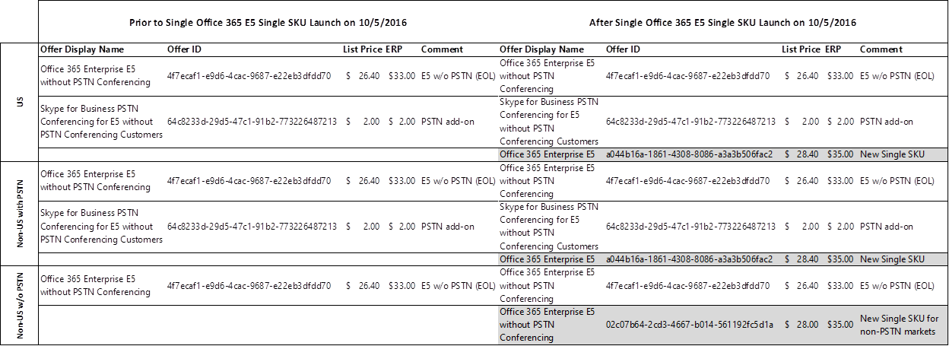

## Skype for Business Features

What is Cloud PBX?

Cloud PBX (PBX: Private Branch Exchange), enables users to make calls to, and receive and transfer calls from phones, mobiles, tablets and PC’s, using their underlying telephone service provider, from nearly anywhere with internet access. IT administrators can manage users for communications in the Office 365 administrator portal. Companies can take advantage of existing telephony infrastructure (i.e. traditional PBX systems or on-premises SIP trunks). With our Cloud PBX, customers can eliminate separate PBX systems.

For additional information, refer to the [Here’s what you get with Cloud PBX](https://support.office.com/en-US/article/Here-s-what-you-get-with-Cloud-PBX-bc9756d1-8a2f-42c4-98f6-afb17c29231c) support article.

What is PSTN Conferencing?

PSTN Conferencing (PSTN: Public Switched Telephone Network) allows meeting attendees to dial-in to Skype meetings from virtually any device. Meeting organizers can also dial-out to attendees to connect them to the audio portion of the meeting. Companies can consolidate conferencing solutions and simplify operations while reducing complexity and support costs for IT while enabling employees to work from virtually anywhere.

For additional information, refer to the [Dial-in Conferencing in Office 365](https://support.office.com/en-us/article/Dial-in-conferencing-in-Office-365-90d51188-0ba9-4dc4-bd6c-ae11dd1f8551?ui=en-US&rs=en-US&ad=US) article.

What is PSTN Calling?

PSTN Calling provides Domestic and international calling plans with Skype for Business. This allows organizations to subscribe to calling plans from Office 365, using existing phone numbers or getting new ones.

For additional information, refer to the [What is PSTN Calling](https://support.office.com/en-us/article/What-is-PSTN-calling-3dc773b9-95e0-4448-b2f1-887c54022429?ui=en-US&rs=en-US&ad=US) article.

Can I upgrade to PSTN Conferencing and PSTN Calling on E1 and E3?

Yes, customers with E1 and E3 will be able to upgrade to PSTN Conferencing and Cloud PBX + PSTN Calling as standalone offers.

What options does a customer have in order to get PSTN calling with Cloud PBX?

Customers can buy the Microsoft PSTN Calling plan if it is offered in their purchasing program and geography. In addition, using on-premises voice connectivity, customers can connect Cloud PBX to their existing telephony infrastructure such as on-premises SIP trunks offered through their local/regional telco, enabling Cloud PBX to perform call control and call management features.

What licensing, if any, is required for Skype Meeting Broadcast public webinars?

Attendees do not need to have a license to attend a Skype Meeting Broadcast. However, if the organization wants the attendee to be authenticated, then a Skype for Business license is required.

Are there any pre-requisites that need to be purchased and provisioned before a customer can use Cloud PBX, PSTN Conferencing or PSTN Calling?

Yes, in order to use these services, customers must have purchased and have Skype for Business Plan 2, or equivalent E SKU (E1/E3/E4/E5), deployed as a standalone or as a component of Office 365 E1, E3, or E5 suites. To use PSTN Calling, customers must also purchase Cloud PBX or E5 (which includes Cloud PBX functionality) as a pre-requisite.

How can existing customers purchase Cloud PBX from the Office 365 Admin Console?

Cloud PBX does not show in your Office 365 Admin Console until Skype for Business Server, Cloud Connector Edition and/or PSTN Calling has been connected with and provisioned into your Office 365 tenant. Please work with your local Account team or Partner to setup your PSTN connectivity accordingly.

Can a customer who has Skype for Business on-prem use PSTN Conferencing and PSTN Calling through a hybrid model?

E5 and Cloud PBX customers will be able to connect their existing PSTN service provider with Microsoft’s cloud-based call control. Scenarios are based on whether a customer already has a Skype for Business Server deployed. Customers can set up a new server pool or they can leverage an existing Skype for Business Server deployment to configure it to connect to Cloud PBX functionality which is covered under existing Server licensing.

For customers without an existing server, they can leverage a minimal Skype for Business Server deployment through the Cloud Connected Edition that will include four preconfigured Virtual Machines that are deployed on customer owned Windows Servers. Skype for Business Server roles in VMs are not paid roles and are licensed for use with Cloud PBX.

Are PSTN services available to Government and GCC (Government Community Cloud – US only) customers?

As of September 1, 2016, PSTN Conferencing will be available to GCC customers as a standalone product.

However, as of September 1, 2016, E5 is still not available to GCC customers, so the new unified E5 SKU will not yet be available in GCC.

Does Microsoft have plans to become a Telco?

To the extent our new Skype for Business offering includes features that are subject to telecom regulation, Microsoft will ensure those features comply with the applicable regulations.  With regard to our long-provided communications capabilities, such as the Skype consumer offerings available in the market today from Skype.com, we have no plans to change or add features that would result in subjecting Skype to telecom regulation.  Moreover, the mere fact that Microsoft will offer an enterprise communications capability that includes regulated features does not in any way change the regulatory status of our other communications products, including Skype.

Is Microsoft competing with Network Operators?

We have existing relationships with network operators through managed services, and we are expanding those to managed networks. With these new services, we continue to deepen our partnerships with network operators across the managed services portfolio for dedicated deployments. In addition, we are expanding our partnerships to include network connectivity services; customers will soon have the option of purchasing Operator services to directly connect their corporate WAN networks to Office 365 and Skype for Business through Azure ExpressRoute for Office 365.

## PSTN Conferencing and Calling Details

When and where will PSTN Conferencing and PSTN Calling be available?

PSTN Conferencing and PSTN Calling, as well as the inclusion of PSTN Conferencing in E5, are subject to geographical and channel availability. Availability for select geographies and licensing programs are noted below:

**PSTN Conferencing**

PSTN Conferencing will be available in 65 countries (otherwise referred to as PSTN Conferencing Sell-to countries) as of September 1, 2016.

Argentina, Australia, Austria, Belgium, Bosnia & Herzegovina, Brazil, Bulgaria, Canada, Chile, Colombia, Costa Rica, Croatia, Czech Republic, Denmark, Dominican Republic, Egypt, Estonia, Finland, France, Germany, Greece, Ireland, Italy, Hungary, Indonesia, Israel, Japan, Latvia, Lithuania, Luxembourg, Malaysia, Malta, Mexico, Monaco, Netherlands, New Zealand, Norway, Peru, Philippines, Poland, Portugal, Puerto Rico, Qatar, Romania, Russia, Serbia, Singapore, Slovak Republic, Slovenia, South Africa, South Korea, Spain, Sri Lanka, Sweden, Switzerland, Taiwan, Thailand, Turkey, UAE, Ukraine, United Kingdom, United States, Uruguay, Venezuela, and Vietnam.

In addition to the Sell-to countries, Tolled Dial-in numbers are available in the following countries:

Bahamas, Bahrain, Belarus, Belize, Brunei, Botswana, China, Cyprus, Ecuador, El Salvador, Georgia, Honduras, Hong Kong, India, Jordan, Kenya, Macedonia, Moldova, Morocco, Nigeria, Pakistan, Panama, Paraguay, Saudi Arabia, St. Kitts and Nevis, and Trinidad and Tobago.

**PSTN Calling**PSTN Calling is only available in the US (which includes the continental US, Alaska, and Hawaii), Puerto Rico, and the United Kingdom. Other markets will be announced at a later date.

For more information, please refer to the [International Availability of Microsoft Online Services](https://products.office.com/en-us/business/international-availability) and the [Is PSTN Conferencing with phone numbers available in my country or region](https://support.office.com/en-us/article/Is-PSTN-Conferencing-with-phone-numbers-available-in-my-country-or-region-1096d81e-7e14-488c-95d8-b8322e39c059?ui=en-US&rs=en-US&ad=US) page on Office.com?

What are the PSTN Conferencing Features?

Skype for Business PSTN Conferencing will include the following features, subject to timing concerns called out in the following section:

**Tolled Dial-in**: This feature enables invitees to meetings organized by a user licensed for PSTN Conferencing to join the audio portion of the meeting by dialing a PSTN number and entering a conference passcode. The number that is generated for meeting attendees to use is a general dial-in number that is assigned at the tenant level and is not specific to an individual user. There are limits on the use of this feature designed to prevent abuse and/or fraud.

**Dial-out**: This feature enables attendees of meetings organized by a user licensed for PSTN Conferencing to:

* Dial out to other users from the meeting
* Transfer an in-progress meeting to a PSTN endpoint from within the meeting
* At meeting join, dial out to a PSTN endpoint
* At meeting join from a mobile client, dial out to the mobile phone
* Dial out calls can be Domestic or International

**Toll-free dial in**: This feature enables attendees of meetings organized by a user licensed for PSTN Conferencing to join meeting by dialing a toll-free number and entering a pin. Toll-free PSTN numbers can either be Domestic or international.

What is the Introductory Offer?

The PSTN Conferencing introductory period end date has been extended to February 1, 2017. This extension is designed to give customers more time to understand and enable PSTN consumption billing. During the introductory period, tenants can continue to dial-out from within a Skype for Business meeting without any cost within fair use unless the destination is noted as a Pay-as-you-go (PAYG) dial-out country. An assigned user will need PSTN consumption billing enabled in order to make a call to a PAYG country. The following is an example of how domestic and international dial out will work.

For more information, refer to the [Field Advisory](https://microsoft.sharepoint.com/sites/infopedia/pages/layouts/kcdoc.aspx?k=G03KC-1-2714) from September 1, 2016.

What is an *Included Dial Out* country and what is a *Pay as You Go Dial Out* country?

For PSTN Conferencing services, there is a distinction between two types of countries. Countries that are considered *Included Dial Out* will have Domestic Dial-out Conferencing included as part of their service plan as of February 1, 2017.

Countries that are considered *Pay as You Go Dial Out* will not have Domestic Dial-out Conferencing included in their services plans prior to or post February 1, 2017. In order for these latter countries to use Dial-out Conferencing services, they will need to establish a PSTN Consumption Billing account and will be charged by the minute for all Dial-out Conferencing usage.

What are the countries that are Dial Out Included and what are the countries that are Pay as You Go?

Dial Out Included Countries:  
Australia, Austria, Belgium, Brazil, Bulgaria, Canada, Croatia, Czech Republic, Denmark, Estonia, Finland, France, Germany, Greece, Hungary, Ireland, Italy, Japan, Luxembourg, Malaysia, Mexico, Netherlands, New Zealand, Norway, Poland, Portugal, Puerto Rico, Romania, Russia, Singapore, Slovak Republic, Slovenia, South Africa, South Korea, Spain, Sweden, Switzerland, Taiwan, Thailand, United Kingdom, United States

Pay as You Go Countries  
All other countries to which users can be assigned in Office 365.

How will the extended Introductory Offer impact both *Included Dial Out* and *Pay as You Go Dial Out* countries?

The original Introductory Offer that was introduced on 12/1/15 was originally designated to expire on September 1, 2016, with the launch of Consumption services. However, in order to provide customers with enough time to establish PSTN Consumption Billing accounts, the offer will be extended through January 31, 2017.

For all PSTN Conferencing Sell-to countries, the offer will enable Dial Out Conferencing to all *Included Dial Out* Countries as an included part of the service plan. This essentially means that *Included Dial Out* Countries will be able to Dial Out both Domestically and to the other 43 *Included Dial Out* Countries without requiring PSTN Consumption until February 1, 2017. Whereas *Pay As You Go Dial Out* Countries will be able to Dial Out to all 44 *Included Dial Out* Countries without requiring PSTN Consumption, but will still require PSTN Consumption to Dial Out Domestically.

After the introductory period ends on February 1, 2017, *Included Dial Out* Countries will only be able to Dial Out Domestically without PSTN Consumption and *Pay As You Go Dial Out* Countries will require PSTN Consumption for all Dial Out Conferencing (including Domestic).

Dial out Scenarios through the Introductory Period ending 2/1/2017

|  |  |  |  |
| --- | --- | --- | --- |
| **Assigned Meeting Organizer Location where Dial-out call is made** | **Dial-out to destination country** | | |
| **US**  **(Included Dial-out Country)** | **France**  **(Included Dial-out Country)** | **Argentina**  **(PAYG Dial-out Country)** |
| US | Included | Included | PAYG* |
| France | Included | Included | PAYG* |
| Argentina | Included | Included | PAYG* |

*PSTN Consumption billing is required for this scenario

Dial out Scenarios post 2/1/2017

|  |  |  |  |
| --- | --- | --- | --- |
| **Assigned Meeting Organizer Location where Dial-out call is made** | **Dial-out to destination country** | | |
| **US**  **(Included Dial-out Country)** | **France**  **(Included Dial-out Country)** | **Argentina**  **(PAYG Dial-out Country)** |
| US | Included | PAYG* | PAYG* |
| France | PAYG* | Included | PAYG* |
| Argentina | PAYG* | PAYG* | PAYG* |

*PSTN Consumption billing is required for this scenario

Why is Microsoft establishing a distinction between the Included and Pay as You Go countries?

Telephony service charges vary greatly from one country to another. While some countries have relatively cheap telephony rates, other countries are significantly more expensive. It is Microsoft’s goal to include Domestic Dial-out Conferencing services in all countries where PSTN Conferencing is available, however the increased cost of telephony services in several countries makes it prohibitive for Microsoft to do so.

Why can a PAYG country call to an Included Dial-out Country for free during the Introductory Period yet Domestic Dial-out calls will be charged?

Until the Introductory Period ends on 2/1/17, PAYG Countries will be able to Dial-out for free to all countries listed as *Included Dial-out* countries. However, Dialing-out to countries on the PAYG list will require that they have consumption billing enabled, this includes calling Domestically given the user is in a PAYG countries.

Is there specific partner guidance that prohibits the sale of E5 and Skype for Business services into countries?

Yes, E5 and Skype for Business services are NOT for sale in countries outside of the sell-to countries (see disclaimers on price list) and must not be sold to customers with bill-to addresses outside of the designated sell-to countries.  As such, the E5 and Skype for Business services cannot be marketed locally and marketing materials cannot be localized for any countries outside the sell-to list. This includes promoting any offers to countries outside the sell-to list as well.

What if a customer is located in a PSTN Conferencing Sell-to country but wants to license users located in countries that are not on that list?

Companies with users located in various countries around the world will be able to purchase PSTN services in a Sell-to country (e.g. the Unites States) and then provision their users anywhere in the world with those licenses. For a better understanding of the experiences of different users based on their geo location, see the scenario below.

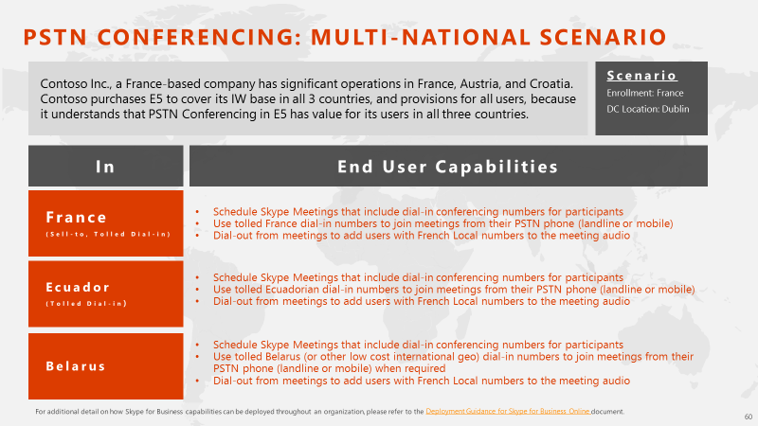

What if a PSTN Calling user is in the US but travels to another country?

Domestic calling, per the [Skype for Business Online PSTN service use terms](https://support.office.com/en-us/article/Skype-for-Business-Online-PSTN-services-use-terms-dc6e95cd-51e8-49ca-bcd3-78dc9dae486a?ui=en-US&rs=en-US&ad=US), is defined as: “The ability for the user to make calls to numbers located within the country of Office 365 assignment for that user.” In other words, if a US based user (meaning their Office 365 license is assigned in the US) travelled to London, any calls they make back to the US would be considered a Domestic call.

Can a company based in a PSTN Calling market (US, UK, PR) assign PSTN Calling services to users based outside of the PSTN Calling market?

PSTN Calling is restricted from both a sell to (billing address) and user location standpoint. Thus, users whose location is not in the PSTN Calling market (US, UK, PR), even in cases where the customer's billing location is in the PSTN Calling market, will not be able to use PSTN Calling plans from Microsoft today.

Will Toll-Free Conferencing capabilities be available worldwide?

Yes – however it will be limited to the same Sell-to country restrictions based on geo availability of the PSTN Conferencing service. Only countries that are on the Sell-to list can be sold PSTN Conferencing services, but those customers can provision their users on a worldwide basis.

Is there additional scenario and deployment guidance that I can refer to?

Yes – please refer to the [Deployment Guidance for Skype for Business Online](http://infopedia/kc02/docstore/_layouts/WopiFrame.aspx?sourcedoc=http%3A//infopedia/kc02/docstore/Repository/Skype%20for%20Business%20-%20To%20Customer/Deployment%20Guidance%20for%20Skype%20for%20Business%20Online.pptx&action=default&DefaultItemOpen=1) document to better understand how Skype for Business capabilities can be deployed throughout an organization.

What is included with PSTN Conferencing service plans? What is additional paid based on consumption?

Services that are included for PSTN Conferencing plans are different for *Included Dial-out* countries and *Pay as You* Go countries. Tolled Dial-in conferencing and Domestic Dial-out conferencing services are both included in the PSTN Conferencing service plans for *Included Dial-out* countries. There are no excessive use limits on Tolled Dial-in. For Dial-out, excessive use limits might be reached in cases of fraud or abuse of the service. Microsoft will monitor the service for fraud or abuse and will reserve the right to limit use in cases where the service quality might be compromised.

For *Pay as You Go Dial-out* countries, Tolled Dial-in Conferencing is included in the service plan. Domestic Dial-out capabilities will require a Consumption Billing plan to be set up in order to use Dial-out conferencing.

Between now and 2/1/17, there is an Introductory Offer in place. Please see the Introductory Offer FAQs for more information.

What is included with PSTN Calling service plans? What is additional paid based on consumption?

For PSTN Calling plans, inbound Domestic calls, outbound Domestic calls, and International calls are included with the service in accordance with our excessive use limit policy. If the customer exceeds the excessive use limits, the excess minutes will be billed on a per-minute basis.

For all local and international calls placed to users within the same tenant, Peer to Peer calling will be enabled and the call will be placed over the Voice Over IP network meaning that all local and international calls placed within the tenant will not count towards the excessive use limits.

What are the excessive use limits for PSTN Calling and PSTN Conferencing?

The total minutes of use for the excessive use threshold is calculated at the tenant level based on the number of users licensed for the tenant. There will be a period of time between GA (12/1/15) and the availability of consumption billing (June 1, 2016) where customers will be made aware of their overages via reporting but they will not be charged for their PSTN Calling or Conferencing overages under the excessive use limits. This will serve as an important opportunity to estimate future billing overage charges.

**PSTN Conferencing**

For PSTN Conferencing there are no excessive use limits on Tolled Dial-in. For Dial-out usage in Included Dial-out countries, excessive use limits might be reached in cases of fraud or abuse of the service. Microsoft will monitor the service for fraud or abuse and will reserve the right to limit use in cases where the service quality might be compromised.

**PSTN Calling**

For PSTN Calling, excessive use is defined as follows:

* For Domestic PSTN Calling plans in the United States and Puerto Rico, each licensed user is allocated 3,000 Domestic dial-out minutes that are pooled at the tenant-level. For the United Kingdom, each user is allocated 1,200 Domestic dial-out minutes that are pooled at the tenant-level.
* For International PSTN Calling plans, each licensed user is allocated the aforementioned Domestic dial-out minutes and 600 International dial out outbound minutes that are pooled at the tenant-level.

Are PSTN Calling Domestic and International minutes pooled together at the tenant level?

No – minutes for PSTN Calling are pooled by plan type. For example, if a customer licenses ten users with PSTN Domestic Calling, they would have 30,000 pooled minutes for domestic calling use between those ten users for PSTN Domestic calls only.

If that same customer licensed five users with PSTN International Calling in the US, they would have 3,000 pooled minutes for international calling use and 15,000 minutes of domestic calling use between those five users.

If the Domestic Calling plan users reach their 30,000-minute threshold, then the users on the International Plan would not get cut off, only the users on the Domestic Calling plan would go into Consumption mode and vice versa.

For the International Calling plan users, should they consume all 3,000 International minutes, they would then go into Consumption mode for both their Domestic and International minutes, or vice versa.

What services will incur consumption billing and which will not?

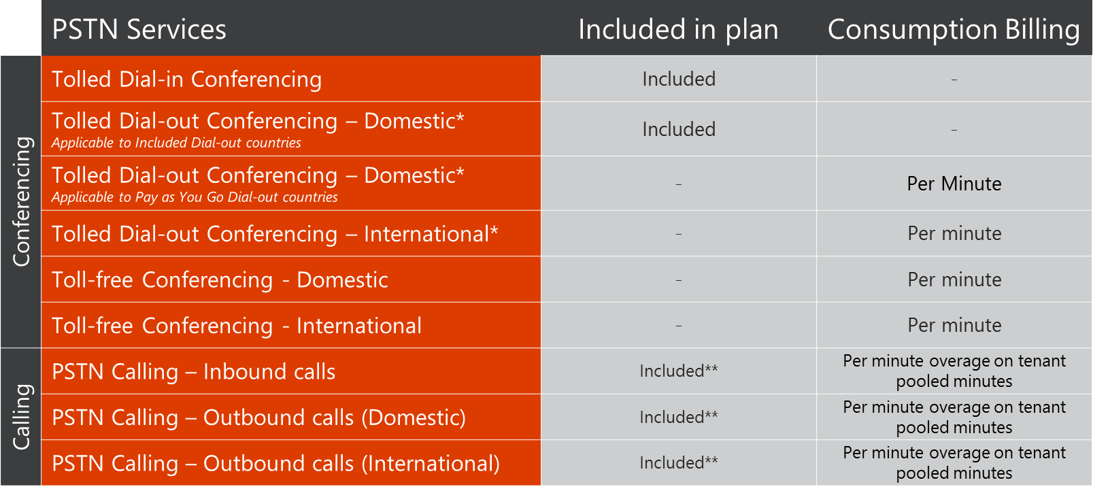

**See Introductory Offer period details.

*** In the US and PR, PSTN Calling plans will be subject to excessive use limits of 3,000 total minutes used for inbound calls and Domestic outbound calls per user and 600 total outbound minutes per user of International calling. In the UK, PSTN Calling plans will include 1,200 Domestic minutes and 600 International minutes. Minutes will be pooled at the tenant-level and excess use charges will be incurred and billed by the minute when the usage limits are exceeded for either Domestic or International allocations. For all local and international calls placed to users within the same tenant, Peer to Peer calling will be enabled and the call will be placed over the voice over IP network – all local and international calls placed within the tenant will not count towards the excessive use limits.

What is considered Domestic Calling?

Domestic calling in the context of a meeting is based on the Office 365 assigned country location of the meeting organizer. An organizer whose assigned location is in France will have Domestic calling for French numbers, and International calling for all other numbers.

What if a customer exceeds their PSTN Calling minute allocation?

Provided that they have enabled PSTN Consumption billing, if a customer exceeds either their domestic or International PSTN Calling plan allocation the customer will be charged for their usage. Thus if a US-based tenant exhausts the 3,000 domestic calling minutes of their calling plan, they will be charged by the minute for any domestic or international dial-out calls made in excess of the 3,000 domestic minutes, regardless of how many minutes were left in their International plan.

If the customer has not enabled PSTN Consumption Billing and they reach either their Domestic or International calling limits, their service will be suspended for the remainder of the month.

What if an individual user’s PSTN Calling usage went above the allocation limit in a monthly period, will the customer be charged?

Not necessarily – overage charges are only applied if the customer’s overall usage in a monthly period exceeds the tenant-pooled limits. If an individual user goes beyond their user limit of 3,000 Domestic minutes, for example, but the overall tenant-pooled limit threshold wasn’t breached, then no, the customer will not be charged for any overages.

Will unused PSTN Calling minutes be rolled over to the next month’s billing cycle?

No – domestic and international minute allocations will be based on a monthly cycle. Any minutes that were unused during the month will not rollover to the next month.

When will customers be billed when they create a Consumption Billing account by depositing funds, or when they top-up their accounts?

Any deposits made to consumption billing accounts will be invoiced to the customer at the time of transaction.

What if a PSTN Calling user makes a Domestic or International call to another user in the same tenant?

Calls placed to other users whose license resides in the same Office 365 tenant, domestic or international, will not count towards the excessive use limits for PSTN Calling. When calls are placed within the same tenant, reverse number lookup functionality will validate that the call originated in the same tenant and it will be placed as a peer to peer call on the Voice Over IP network, if available.

What rates will be applied to customers who have users provisioned in different countries around the world?

Per minute consumption billing charges will be calculated using the published rates that correspond to the billing address that is associated with the tenant. For example, if a US based company has users provisioned in the US, the United Kingdom, and France, and their tenant enrollment’s billing address is in the US, all users across the US, United Kingdom, and France will be subject to US published rates on all per-minute charges.

Will the per-minute pricing be published in the Customer Pricing Sheet?

No. We want the latitude to drive our customers’ price for PSTN Services down over the term of our customer contract. Therefore, the CPS will not lock in multi-year per minute pricing.

Will Consumption Billing rates be fixed and where will they be published?

No, the per minute consumption rates for PSTN Conferencing Toll Free, PSTN Conferencing Domestic Dial-out, PSTN Conferencing International Dial-Out, and additional PSTN Calling minutes will not be fixed. They will be published on the Office 365 Portal. Prior to publishing on the Portal, they are currently available [here](https://microsoft.sharepoint.com/sites/infopedia/pages/layouts/KCDoc.aspx?k=G03KC-1-6106).

How will customers pay for their consumption charges for PSTN Conferencing and Calling?

Consumption Billing for PSTN services will launch on September 1, 2016, enabling PSTN Conferencing toll-free dial-in, international dialing for users with PSTN domestic calling, and additional domestic and international calling minutes. For additional information on PSTN Consumption Billing, please see the [What is PSTN Consumption Billing](https://support.office.com/en-us/article/What-is-PSTN-consumption-billing-524dbea7-117f-493d-8005-6461f7f10059?ui=en-US&rs=en-US&ad=US) article on Office.com.

How long will funds remain active in a customer’s Consumption Billing account?

Funds in a customer’s Consumption Billing account will remain active for a period of 12 months. Any funds not used within that period will expire 12 months after the date when the funds were originally deposited into a customer’s Consumption Billing account.

For example, if a customer deposits $100 into their Consumption Billing account on January 1, 2017 and only uses $80 through the course of the 12 months, the remaining $20 will expire on January 1, 2018. In the event that a customer replenishes their Consumption Billing account at any point throughout the 12 months, the replenished funds can be used within 12 months from the date that the account was replenished. In cases where customers have a minimum threshold amount established that triggers an account replenishment (for example, once a customer’s account reaches $20, it will automatically be replenished with an additional $50), the remaining $20 from the previous account deposit will be used first to help the customer avoid losing those funds after 12 months from the date of the original deposit.

Will customers be able to track their usage?

Yes. Usage reporting will be available via the Skype for Business Admin Center.

Further, customers will have the ability to restrict usage to certain users if they feel they are at risk of exceeding their monthly tenant-pooled limits.

How will the Skype for Business PSTN Consumption Billing offering impact our Partners?

For each partner channel, consumption billing will be available in the following ways:

**CSP:**At launch on 9/1, CSP partners will not be able to see the consumption billing catalogue, and thus will not have the ability to buy and resell the PSTN Consumption offer for their customers. However, a CSP Customer could access their O365 portal using their admin credentials where they would see the Consumption Billing plan in their catalogue and buy it as a MOSP/Web Direct customer. Consumption billing availability for CSP partners will be communicated at a future date

**Open:**There are no plans to sell PSTN Consumption via Open at this time. An Open customer that accesses their Office 365 portal will be presented the MOSP catalog and thus be able to add PSTN Consumption to their Tenant via MOSP (like a CSP customer)

**EA:**We will sell PSTN Consumption for EA Indirect customers on 9/1. The Office 365 portal will recognize an EA customer by looking for EA Enrollments on the Tenant associated with the account. If there is an EA Enrollment, the UI will only present the corresponding EA Enrollments as a payment instrument.

**MOSP:**We will sell PSTN Consumption via MOSP on 9/1**.** Customers that buy via web direct and meet the pre requisites will be offered the PSTN Consumption offer

Is PSTN Consumption Billing available for GCC or Nonprofit?

Not at this time. More details will be available at a future date.

Will Microsoft provide phone numbers for PSTN Calling plans?

Yes, it is possible to assign users phone numbers directly through the Skype for Business admin center. For additional information, refer to the [Getting phone numbers for your users](https://support.office.com/en-us/article/Getting-phone-numbers-for-your-users-aa2ec464-3481-4bbb-8c14-e13e18093df5?ui=en-US&rs=en-US&ad=US) article. If your users already have phone numbers assigned by another provider, it is possible to transfer those existing phone numbers from your service provider or phone carrier.

Customers can acquire 10% additional new telephone phone numbers for which they have licenses. For example, if a customer purchases 100 licenses, they can acquire up to 110 new telephone numbers.

Please note: the aforementioned applies only to acquiring NEW telephone numbers through Office 365 and Skype for Business; there is no limit on porting in telephone numbers to our service; if the customer owns the telephone number, they can port in any quantity of telephone numbers regardless of the number of licenses they possess.

Will there be guidance available to customers and partners on how to port over existing phone numbers to the PSTN Calling service?

Yes, there will be a self-service form on the Office 365 Admin portal. For customers who have more than 150 users, they will be able to engage with a FastTrack engineer to assist with the process.

For additional information, refer to the [Transfer phone numbers over to Skype for Business Online](https://support.office.com/en-us/article/Transfer-phone-numbers-over-to-Skype-for-Business-Online-47b3af8e-4171-4dec-8333-c956f108664e?ui=en-US&rs=en-US&ad=US) article.

Can a customer use an IP phone with PSTN Calling? What other phones will be supported?

Yes, users can make and receive phone calls using Skype for Business IP phones, PCs and mobile devices. For additional information, refer to the [Supported phones for Skype for Business Online](https://support.office.com/en-us/article/Getting-phones-for-Skype-for-Business-Online-91f2d947-45fc-4fab-bd8b-2e313531c477?ui=en-US&rs=en-US&ad=US) article.

If a customer has a Domestic Calling plan, would they be able to place an international call?

No – the call would not connect.

How many Domestic Dial-in (DID) numbers will a user be assigned per license?

An end-user will be assigned one DID number per license – one license, one number. If for any reason a customer would like to have additional DID numbers for their organization, they would have to pay for those additional licenses.

What will be the experience for customers who will not get a Domestic PSTN conferencing tolled dial-in number, but will be provisioned with the service?

Users licensed to use the PSTN Conferencing service who do not have a domestic tolled PSTN dial in number will be able to invite others to Skype meetings and have a domestic PSTN dial in number available to them in their domestic area if they are located in the same domestic geography as a dial in number. If not, these invitees can connect to audio using VoIP from their PC, tablet, or mobile phone or by dialing a number in a relatively inexpensive international geography. The organizers who do not have a domestic dial in number will have the same choice of options-- connecting to audio using VoIP from their PC, tablet, or mobile phone or by dialing a number in a relatively inexpensive international geography.

Will we ever have calling plans that are billed strictly based on usage?

Future calling plans are not covered in this document.

Do the EA VL Discounting levels apply to subscription pricing?

Yes, EA VL discounting levels and pricing waterfalls apply to subscription pricing.

Are the prices for PSTN services tax inclusive?

In the United States the prices for PSTN services are tax inclusive. In the other countries the prices for these services are tax exclusive.

Does Microsoft have plans to make PSTN Conferencing a service that is supported for customers running Skype IM/Conferencing on-premise?

We are making investments to bring value to our on-premises customers via online services to help them realize value from our investments in new online services. As delivery dates become clearer, these will be disclosed in the Skype for Business futures deck, available at [http://ucweb](http://ucweb/).

Skype for Business Online PSTN service use terms

For additional information, please refer to the [Skype for Business Online service use terms](https://support.office.com/en-us/article/Skype-for-Business-Online-PSTN-services-use-terms-dc6e95cd-51e8-49ca-bcd3-78dc9dae486a?ui=en-US&rs=en-US&ad=US).

## Feature Details

### Customer Lockbox

**Description**: Customer Lockbox ensures that no one at Microsoft can access customer content to perform a service operation without the customer’s explicit approval. Customer Lockbox brings the customer into the approval workflow for such access to customer content. As customers move data to Office 365, they may be concerned about access to their data in the service by the service provider. In the rare cases, when a Microsoft employee needs access to customer content to perform a service operation, Customer Lockbox provides customers with the ability to approve or reject requests for access.

**Resources**[Customer Lockbox FAQ](https://microsoft.sharepoint.com/sites/infopedia/pages/layouts/KCDoc.aspx?k=G03KC-1-6536)  
[Announcing Customer Lockbox for Office 365 Blog Post](https://blogs.office.com/2015/04/21/announcing-customer-lockbox-for-office-365/)

Is Customer Lockbox available to all Office 365 customers?

Our plan is to make Customer Lockbox available to Office 365 enterprise service families, as described [here](https://technet.microsoft.com/en-us/library/office-365-plan-options.aspx).

If a customer were to purchase Customer Lockbox stand-alone, would it be licensed as a Full USL or a Cloud Add-on?

Customer Lockbox will be licensed as a Full USL and is considered a product add-on. It is not a cloud add-on.

What are the prerequisites to purchasing Customer Lockbox?

A customer must already be licenses with either Exchange Online Plan 1 or 2, SharePoint Online Plan 1 or 2, or Office 365 E1 or E3.

If a customer only licenses some of their users on Customer Lockbox, will the non-licensed users also receive Customer Lockbox?

Users must be licensed for Customer Lockbox to ensure that they will receive the feature.  For customers who license Customer Lockbox for a subset of users, Microsoft does not commit to providing Customer Lockbox access control approval requests for the users who are not licensed. Customers should license any users for whom they want Customer Lockbox.

### Office 365 Advanced eDiscovery

**Description**: Office 365 Advanced eDiscovery integrates machine learning, predictive coding and text analytics capabilities, to reduce the costs and challenges that come along with sorting through large quantities of data for eDiscovery purposes. In today’s data environment, the eDiscovery process for any given case could involve sorting through millions of emails, text messages, instant messages and documents to find the small number of files that are most relevant. Office 365 Advanced eDiscovery reduces the volume of data by eliminating duplicate files, reconstructing email threads and identifying key themes and data relationships. Finally, it enables users to train the system to intelligently explore and analyze large, unstructured data sets and quickly zero in on what is relevant.

**Resources:**[Office 365 Advanced eDiscovery FAQ](https://microsoft.sharepoint.com/sites/infopedia/pages/layouts/KCDoc.aspx?k=G03KC-1-6162)[Microsoft Ignite Series – eDiscovery Redefined: Real Time and In-Place](https://channel9.msdn.com/events/Ignite/2015/BRK3121)

Is the support and serviceability story for Advanced eDiscovery the same as rest of E5 SKU?

Advanced eDiscovery is part of Office 365 E5, so it will be supported like any other functionality you get with E5 SKU. It is also a service, so we will be updating the service continuously with new features, bug fixes etc.

How does licensing work?

To analyze a user’s data with Advanced eDiscovery, the user being analyzed must have an E5 license. The user performing tasks in Advanced eDiscovery does not need a license.

Is Advanced eDiscovery available as a standalone option or only as part of E5?

Yes, you will be able to purchase Advanced eDiscovery licenses separately from E5

### Office 365 Advanced Threat Protection

**Description**: Office 365 ATP is a collection of features, including Safe Attachments and Safe Links, designed to combat zero-day malware attacks. Safe Attachments is a new feature that opens suspected unknown attachment in a special hypervisor environment and detects malicious activity. It is designed to detect malicious attachments even before anti-virus signatures are available. Safe Links is a feature that prevents users from going to malicious web sites when they click on them in email and provides advanced reporting features that make it easy to determine who has clicked through a malicious link to support faster remediation.

**Resources**[Office 365 Advanced Threat Protection FAQ](https://microsoft.sharepoint.com/sites/infopedia/pages/layouts/kcdoc.aspx?k=KC02-23-66754)[Microsoft Ignite Series – Overview recording](http://channel9.msdn.com/events/Ignite/2015/BRK2198)  
[Microsoft Ignite Series – Deep Dive Session recording](http://channel9.msdn.com/events/Ignite/2015/BRK3106)  
[Advanced threat protection for safe attachments and safe links](https://technet.microsoft.com/en-us/library/mt148491(v=exchg.150).aspx)

Will this service be included in any existing Office 365 plans?

Yes – Office 365 ATP is included in Office 365 E5. It can also be purchased as a standalone product with E1 and E3.

Are there any prerequisites for Office 365 ATP?

Yes, Office 365 ATP requires Exchange Online Plan 1 or 2.

Can Office 365 ATP be used on Shared Mailboxes, and if so, does it need to be licensed?

Yes. Although standard Shared Mailboxes do not require licenses, advanced functionality like Office 365 ATP and In-place Hold require licenses. In this case, the Shared Mailbox would need to be licensed for Office 365 ATP along with Exchange Online.

My customer wants to assign Office 365 ATP to a Shared Mailbox, but they are unable to assign the Office 365 ATP license and the Exchange Online license to the same mailbox. What should they do?

The system does not currently allow multiple licenses to be assigned to a Shared Mailbox. However, if a customer wants Office 365 ATP, they need to purchase the licenses required for Office 365 ATP in order to stay within compliance. Until the ability to assign multiple licenses becomes available, the customer should purchase both the Office 365 ATP and Exchange Online licenses, but assign only the Exchange Online license to the mailbox.

Is the service available to Office 365 Dedicated customers?

EXO-ATP is not supported with EXO Dedicated.  Customers can start using the service once they have migrated to EXO vNext.

### 

### Power BI Pro

**Description**: Business analytics service that enables information workers to visualize and analyze data with greater speed, efficiency, and understanding through live data dashboards, interactive reports, and compelling visualizations.

**Resources**[Power BI Pro Detailed FAQ](https://microsoft.sharepoint.com/sites/infopedia/pages/layouts/kcdoc.aspx?k=G01KC-1-2286)[Microsoft Ignite Series Recordings](https://channel9.msdn.com/Events/Ignite/2015?sort=sequential&direction=desc&term=power%20bi#theSessions)  
[Microsoft Power BI Knowledge Base](https://support.powerbi.com/knowledgebase)

### Delve Analytics

**Description**: Rich interactive dashboards highlighting key trends such as reach, influence and work-life balance across an individual and team’s engagement with internal and external teams. Delve Analytics is an application that leverages rich insights derived from your communications and collaborations data to help you optimize your activities for the highest impact. Delve analytics will help individuals and teams get time back and spend it effectively by providing visibility into insights about how you actually work. You and your team can be more effective with Delve Analytics – work analytics for the enterprise.

**Resources**[Delve Analytics FAQ](https://microsoft-my.sharepoint.com/personal/nickrob_microsoft_com/_layouts/15/guestaccess.aspx?guestaccesstoken=BQO9IGWp3pKgQLn%2f5bbyub%2ffKh9yrOSgF%2bBI2pxIGtM%3d&docid=2_15294108df943484cbe48ab3adc617bb4)[Office Delve and Office Graph Vision and Roadmap](https://channel9.msdn.com/Events/Ignite/2015/BRK1105)[Break Down Organizational Silos and Gain New Insights with Office Graph and Office Delve](https://channel9.msdn.com/Events/Ignite/2015/BRK2107)

What Office 365 plans include Delve Analytics

Delve Analytics will be available as a part of E5, or as an add-on to E1/ E3 plans.

Do I need each user licensed to enable organization and team analytics views?

Yes, each user needs to be licensed for Delve Analytics as part of E5 or as an add-on to E1/ E3 in order for their data to be contributed as aggregated and anonymous inputs for team scenarios.

### DLP and Encryption

**Description**: Extending Data Loss Prevention and Data Encryption at rest to SharePoint Online in addition to Exchange Online.

**Resources**[Overview of data loss prevention policies](https://technet.microsoft.com/EN-US/library/ms.o365.cc.dlplandingpage.aspx)

### Meeting Broadcast

**Description**: Enables hosting meetings to reach thousands of attendees, with unique large meeting features.

**Resources**[What is a Skype Meeting Broadcast?](https://support.office.com/en-US/article/What-is-a-Skype-Meeting-Broadcast-c472c76b-21f1-4e4b-ab58-329a6c33757d)

What is Skype Meeting Broadcast and how is it enabled?

Skype Meeting Broadcast is a new exciting feature in Office 365 available to all organizations, except those with Education, Government or Non-Profit subscriptions. In order to be able to use this feature, IT Admins of Office 365 tenants will need to manually turn on the feature.

Skype Meeting Broadcast enables Office 365 users to produce and broadcast a Skype for Business meeting on the internet with up to 10,000 attendees, who can attend from a browser on virtually any device. Skype Meeting Broadcast makes it easy to host large virtual meetings like internal “Town Hall” style meetings and public webinars.

Distribution of the media content of a broadcast meeting utilizes Microsoft Azure's Content Delivery Network (CDN) to achieve very high scale to support thousands of people watching a broadcast. The chunked media content passing through the CDN is encrypted, and the CDN cache has a limited lifetime. Because Azure CDN is not included in the services that commit to meeting the EU Standard Contractual Clauses, Skype Meeting Broadcast has been disabled by default for all data center regions.

Do authenticated users require a Skype for Business license to join a Skype Meeting Broadcast?

Yes, all authenticated users joining a Skype Meeting Broadcast must be have a Skype for Business license through any means (e.g. Skype for Business Plan 2, Office 365 E3, etc.).

Where can the IT Admin find information about Skype Meeting Broadcast?

IT Admins can find more information about Skype Meeting Broadcast at the following page:   
<https://support.office.com/article/Set-up-Skype-Meeting-Broadcast-dfa736b9-4920-4f48-b8c0-b5487ec6086f>

Where can the IT Admin find information to enable Skype Meeting Broadcast?

IT Admins can find step by step instructions at the following page:   
<https://support.office.com/article/Enable-your-organization-for-Skype-Meeting-Broadcast-5299cce0-850e-42dc-b6ae-2d0ee775c4a9>

Can you provide some articulation of the actual risk of using Meeting Broadcast?

When a Customer uses Meeting Broadcast, encrypted data chunks containing meeting content are placed on the Azure Content Delivery Network (CDN) and the encryption key is not shared with the CDN. Meeting content data may be temporarily cached nearer meeting attendees for improved service performance but whether in transit or temporarily cached the meeting content remains encrypted until decrypted on the client side for attendees.

Are any other Skype for Business services in Office 365 affected?

No.

### Office 365 Planner

**Description**: Planner offers people a simple and highly visual way to organize teamwork. Planner makes it easy for your team to create new plans, organize and assign tasks, share files, chat about what you’re working on, and get updates on progress. Planner can be used to manage a marketing event, brainstorm new product ideas, track a school project, prepare for a customer visit, or just organize your team more effectively.

**Resources**[Introducing Office 365 Planner](https://blogs.office.com/2015/09/22/introducing-office-365-planner/)

Why can’t I access “Planner Preview” that I see in my license center?

Planner preview is only available to those Office 365 customers who have opted-in for the First Release program. Setup instructions will be sent to Office 365 admins once Planner preview is available for use within their tenant.

### 

### Office 365 Advanced Security Management

**Description**: The cloud offers many security benefits to organizations, but also raises new security considerations. It can also add to existing ones such as shadow IT - the use of software that is not formally sanctioned by the organization. Advanced Security Management includes:

* Threat detection—Helps you identify high-risk and abnormal usage, and security incidents.
* Enhanced control—Shapes your Office 365 environment leveraging granular controls and security policies.
* Discovery and insights—Get enhanced visibility into your Office 365 usage and shadow IT without installing an end point agent.

**Resources**[Advanced Security Management FAQ](https://microsoft.sharepoint.com/sites/infopedia/pages/layouts/KCDoc.aspx?k=G03KC-1-5971)

## E5 Dynamics CRM Online Add on

What is the Dynamics CRM Online Add On?

The [Maximize Sales Productivity Solution](https://microsoft.sharepoint.com/teams/OfficeOnRamp/SitePages/CloudProductivityCampaign.aspx#Sales-Productivity) (E5 + Dynamics CRM Online) represents a $7.1 Billion Opportunity. The [Dynamics CRM Online Add on to E5](http://infopedia/kc02/docstore/Repository/Forms/Enterprise%20Domain/docsethomepage.aspx?ID=77987&FolderCTID=0x0120D520000E4CB7077FEE4FF7AE86D4A500EEC78001006BBF5604762BFA4C9FD87716608D5E8800CCE738C9030E514BA956C9558596B3F2&List=5db00597-85a4-4bd9-8edb-536b2fb20cbc&RootFolder=%2Fkc02%2Fdocstore%2FRepository%2FAutumn%202015%20Sales%20Productivity%20Changes&RecSrc=%2Fkc02%2Fdocstore%2FRepository%2FAutumn%202015%20Sales%20Productivity%20Changes) is a more permanent, programmatic, way of providing a discount (23%) on CRM Online Professional to new or existing Office 365 customers.

What is the combined value of Dynamics CRM Online and Office 365 E5?

Currently **Microsoft Dynamics CRM Online** is the only Sales and Service solution fully integrated with Office 365 from the ground up. Microsoft Dynamics CRM Online 2016 offers:

* Out of the box Office 365 integration with Outlook (Relevant customer information surfaced in your Inbox and auto message tracking)
* Skype for Business (presence and click-to-call from within CRM)
* Yammer (conversations in context of customer information),
* Seamless access to sales and service documents across SharePoint, Office 365 Groups, and OneDrive for Business
* Surface trending documents from Delve in CRM dashboards
* Excel (dynamic worksheet updates from CRM),
* Power BI connector with pre-built sales and service analytics content packs (data exploration and what-if analysis of customer and business data).
* Centralized platform for administration and authentication for Microsoft Dynamics CRM Online and Office 365
* Native apps for iPhone, iPad, Android, and Windows devices, Mobile Application Management with Microsoft Intune and next generation Cortana integration that surfaces CRM data to drive proactive interaction and voice-driven CRM.
* Process-guided user experience within Microsoft Dynamics CRM Online drives toward desired outcomes
* Customer Intelligence harnessing the power of machine learning and predictive analytics to deliver intelligent processes for sales, service and marketing - including capabilities like intelligent product suggestions (like up-sell / cross-sell) and recommended cases and knowledge to resolve customer service cases.
* Unified Customer Serviceacross self, assisted and field service that empowers customer service agents to deliver fast, informed and effective resolutions and seamlessly incorporates field solutions when there is need for onsite help. Provides a native Knowledge Management solution in CRM and surveys to capture voice of the customer.

What is the pricing SKU Strategy?

**CRM Online Add-On to O365 made easier…**

* Sales Productivity & Service Productivity Solution
* Easier to transact, eligible for discount
* Supports new E5 GTM
* Cross-Program/Segment availability
* In market as of 10/1 with extensive readiness

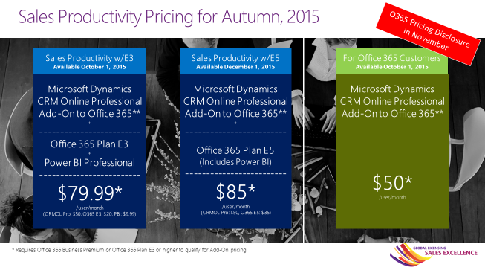

**Where can I find more information about the CRM Online Add on Pricing and Value?**

* Internal Ready deck is located [here](http://infopedia/docstore/pages/kcdoc.aspx?k=KC02-23-77988) on Infopedia. Partner Ready deck is located [here](https://mbs.microsoft.com/Files/partner/All_Products/SalesMarketing/MarketingCollateral/SalesProductivityChangesPartnerReady.pptx) on PartnerSource.
* All other integrated content will be on the [Office Onramp](https://microsoft.sharepoint.com/teams/OfficeOnRamp/SitePages/Office365E5.aspx) site.
* Dynamics CRM Online Marketing and Sales tools are located here on [Infopedia.](http://infopedia/SMSG/Pages/MicrosoftDynamics-CRM.aspx?SourceURL=http://infopedia/pages/CRM.aspx)